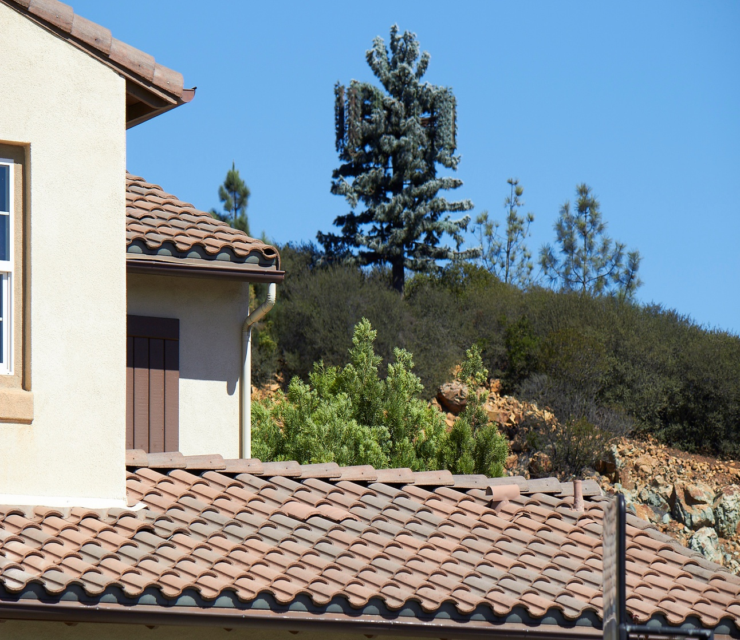
A second AT&T tower, taller and almost twice the diameter, has been approved next to this one by the City of San Marcos.
OCT 22nd APPEAL HEARING!

WANT TO SEE THIS CELL TOWER IN YOUR BACK YARD?
Your Meridian Neighbors are!!!
How About 2 or 3 More Cell Towers?

PLEASE ATTEND THE APPEAL HEARING TUES. OCTOBER 22ND AT 6:00 PM.
City Council Chambers, San Marcos City Hall, 1 Civic Center Drive

How can you support your Neighbors?
- Show up to the Appeal Hearing. You are welcome to bring your kids. Ask your neighbors, friends and family to show their support.
- Email, write or call your city council members:
Jim Desmond, Mayor | jdesmond@san-marcos.net | (760) 402-0448
Rebecca Jones, Vice Mayor | rjones@san-marcos.net | (760) 744-1050
Chris Orlando, Council Member | corlando@san-marcos.net | (760) 744-1050, Ext. 3154
Kristal Jabara, Council Member | kjabara@san-marcos.net | (760) 744-1050
Sharon Jenkins, Council Member | sjenkins@san-marcos.net | (760) 744-1050
- AT&T and the City walked away from a rural location that AT&T admitted provided you better cell coverage and came here to our homes!

Why should you support your neighbors?
- This site was not chosen for the best cell coverage. The AT&T tower location was courted by the homeowner for financial gain. He profits while our property and neighborhood is devalued.
- See for yourself! Walk up Orion, Antilla or Hollowbrook and then imagine more and bigger towers beside this one. Is this how you want your neighborhood to look?
- When this site becomes a “Tower Farm”, it will affect your property value.
- San Marcos does not limit cell tower quantity or distance from your home, the height can be as tall as 50’. Your CC&R’s will not protect you.
- Health issues? Debatable. Most of the world’s population has safe exposure limits at least “10 Times Less” then the FCC’s.
- If our neighborhood was a “tower farm” when you were home shopping, would you have purchased your home?
- The City of San Marcos is NOT representing us, its citizens, but fighting on behalf of the cell companies. They denied us an extension for the Planning Commission Hearing although they gave the Cell companies an extension and over 9 MONTHS to prepare!
- There were no public signs or public hearing warning us - the people of San Elijo Hills.
Support your neighbors, they will support you when you are in need! This is what strong communities do. For more information email: saycellno@gmail.com

